**SL Unit 4** **– Problem Solving**  
Quiz 1

|  |  |  |  |
| --- | --- | --- | --- |
| **Question 1** | | | |
| Objectives: | 5.1.6, 5.1.7 | Exam Reference: | May-15 13 |

1. Theo entered a maze (labyrinth) and tries to get to the centre. As soon as he arrived at

the first possibility to turn right or left, he started recording each move on his phone so that

he could find his way back to the start. He entered the moves as the direction he turned

followed by the number of steps taken before the next turn. For example:

R3 , L5 , L10 , R6 , … , L4

which indicates "TURN **right**, STEP **3**", and then "TURN **left**, STEP **5**" etc.

An app on his phone stored the moves in a stack named STK, using 0 for “right” and 1 for “left”.

The above moves were therefore stored as

0 , 3 , 1 , 5 , 1 , 10 , 0 , 6 , … , 1 , 4.

1. Explain why a stack is a suitable structure to hold the data. [2]

Because items/moves are needed in reverse order;

To the order input;

**OR**

Because it is a LIFO (Last In First Out) data structure;

The items/moves pushed/placed onto the stack;

Will be popped off/taken from it in reverse order (to the order input);

Theo was successful in reaching the centre of the maze and now has to get back to the start.

1. Construct an algorithm, using appropriate stack access methods, to output the moves

needed to return from the centre to the first point where Theo started recording his

moves. You can assume that he is **facing** the correct exit when he starts his return

journey. [5]

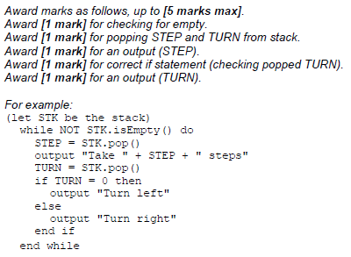

**Another** app on the phone gives Theo a visual representation of his path through a maze as  
 a map. This app makes use of a procedure MOVE(), which outputs the coordinates of Theo’s  
 path through a maze, in reference to the point S, where he first turned right or left and which  
 has coordinates (0, 0).

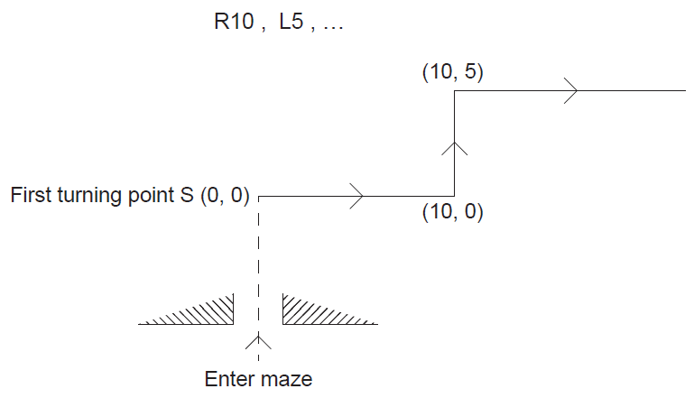 The diagram shows, for a **new maze**, the map from point S given the following moves:

The third move is R8.

1. State the coordinates on the map after this third move. [1]

(18, 5)

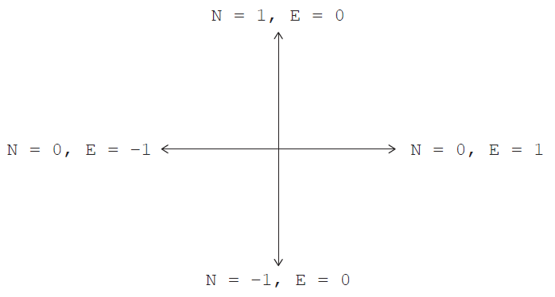 At each point, the direction in which Theo is facing is given by the variables N and E.  
 Note that before the very first turn is made, N = 1 and E = 0.

The following table shows **part** of the trace of MOVE() according to the TURN and STEP  
 values: R10 , L5 , R8 , R2 , L3 , R0.

The last move, with a STEP value of 0, indicates that there are no more moves and that the  
 stack is empty.

1. Complete the table by tracing the algorithm on the following page.

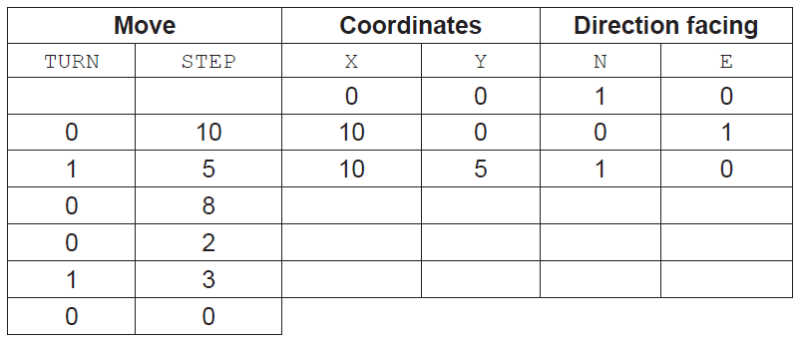

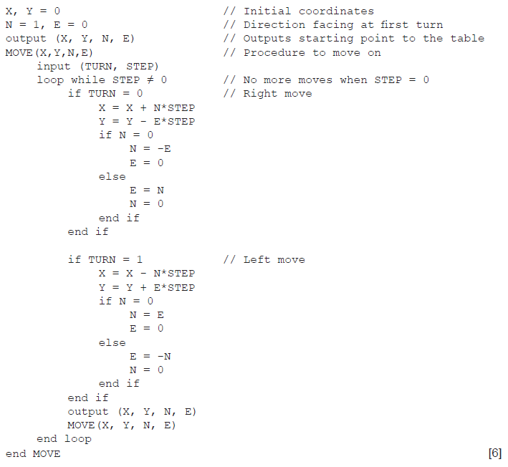

*Award marks as follows up to* ***[6 marks max]****.*

*Award* ***[1 mark]*** *for each correct pair X and Y (coordinates),* ***x3****.*

*Award* ***[1 mark]*** *for each correct change of direction facing (correct E and N),* ***x3****.*

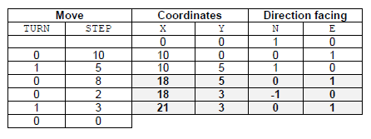

|  |  |  |  |
| --- | --- | --- | --- |
| **Question 2** | | | |
| Objectives: | 5.1.7 | Exam Reference: | May-14 14 |

Consider the following diagram and pseudocode for drawing on a display screen.

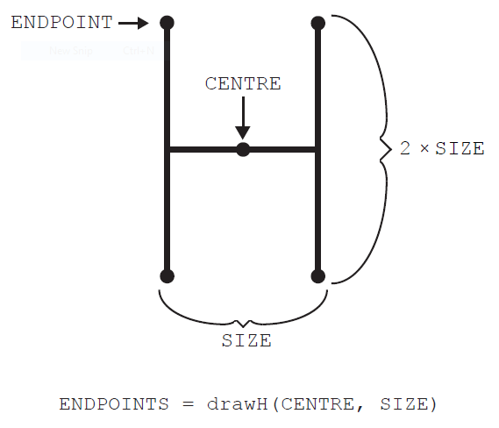

The method drawH(CENTRE, SIZE) will draw an “H” located at CENTRE with width of SIZE

and height of 2 × SIZE, as shown. It returns an array containing the four **endpoints** of the

vertical lines.

In the following flowchart, POINTS1 is a stack.

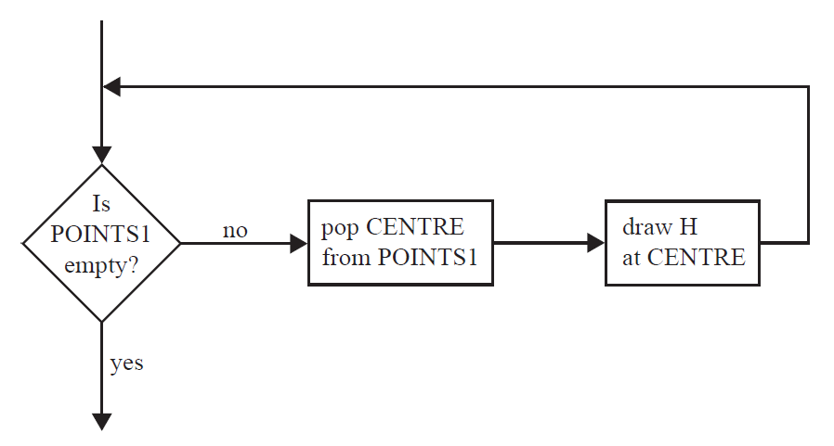

1. Construct pseudocode corresponding to the flowchart. [3]

*Award up to* ***[3 marks max]****.*

*Award* ***[1 mark]*** *for a loop (while).*

*Award* ***[1 mark]*** *for correct condition/logical expression.*

*Award* ***[1 mark]*** *for correct operations.*

loop while NOT POINTS1.isEmpty()

CENTRE = POINTS1.pop()

drawH(CENTRE, SIZE)

end loop

1. Construct the drawing that would be produced by the flowchart on page 6 if it is preceded

by the following steps.

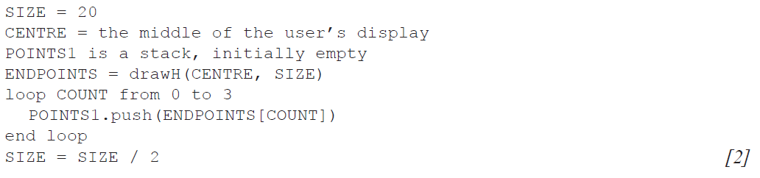

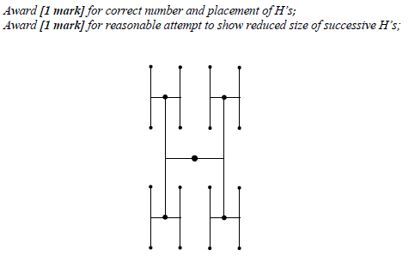

The pattern of drawing a new set of H’s, which have a SIZE value that is half the SIZE value

of the previous H, can be repeated. Each set of H’s of the same size is called a generation.

1. Construct an algorithm that will draw an initial H in the centre of the display and three

generations after that. [6]

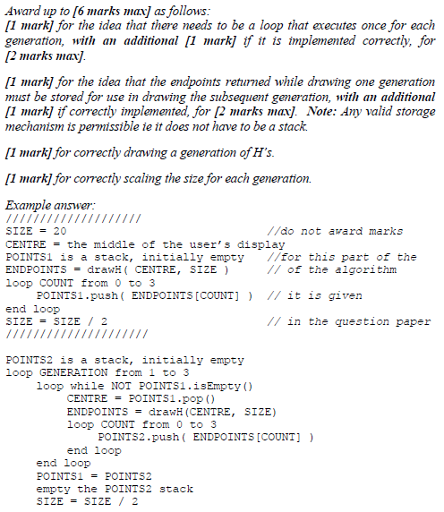

1. State how many endpoints there will be after the initial H and three generations have been drawn, without any consideration of the size. [1]

*Accept any expression appearing in the following equivalences*

4*4*4*4 = 44 = 256;

1. Suggest how drawing this pattern of H’s could be done recursively. [3]

*Award up to* ***[3 marks max]*** *for:*

*identifying that the recursive algorithm proceeds downwards (showing on one*

*parameter will suffice);*

*base case of recursion;*

*recursive call;*

The recursive algorithm would use the parameters centre, size, generation

counting down (not up);

When the generation reached is 0 no drawing is done;

Otherwise draws an H and calls recursively itself on the endpoints of a lower

generation;

|  |  |  |  |
| --- | --- | --- | --- |
| **Question 3** | | | |
| Objectives: | 5.1.9 | Exam Reference: | Ma -14 13 |

The faceplate of a car stereo has six buttons for selecting one of six preferred radio stations.  
As part of the internal representation of a microprocessor there is an array with six positions,

carrying the information about the radio frequencies, as follows.

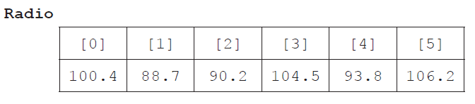

1. State the information at Radio[2]. [1]

90.2

1. Outline how a numerical frequency could be stored in a fixed-length string. [2]

Frequencies less than 100 take a 0 on the left (*eg* 88.7 becomes 088.7);

Convert each digit into a char to get a string;

*Allow the “dot” to be omitted in the interpretation. There is always only one*

*decimal in the example.*

1. Construct an algorithm in pseudocode that calculates the range of frequencies

(ie the difference between the highest and lowest frequencies) of any set of six selected

radio stations. [6]

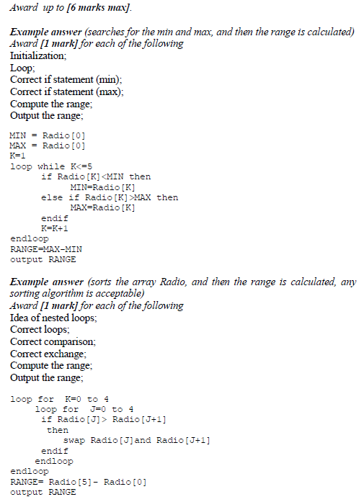

The two-dimensional array Stats provides an indication of how often a specific station is

listened to by the user. For each button in the faceplate it records how often it has been   
 clicke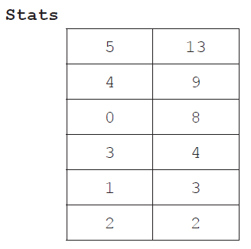d in the last 48 hours. Stats is ordered by the second column.

Both Radio and Stats are used by a procedure that allows the user to access the radio   
 frequencies that are listened to most often, as recorded in Stats, by flicking a lever on the   
 steering wheel. The frequencies are accessed cyclically, ie after the least used frequency the   
 procedure returns to the most used. For this reason a queue **Q** is used.

1. Construct an algorithm in pseudocode that, by using the structures Radio and Stats,

performs the following steps:

* it inserts the radio frequencies in the queue **Q**, following the actual order of preference;

and then

* it uses the queue **Q**, cyclically, to output an element each time the lever is flicked. [6]

